1
RECURSION / RECURSIVE FUNCTIONS
It is the process of calling a function itself.
Purpose:
Recursion allows the user to get results , without using loops. Due to this complexity of program is reduced.
Recursion reduce calling of function by the user.
By using recursion, we can control the function calling information or statements.
By using recursion, we can evaluate stack expressions. Drawbacks:
They are slower than normal functions due to stack over lapping.
They can create stack over flow because of occupying more stack.
Recursion functions will create infinitive loops also. Eg: 1
#include<stdio.h>
#include<conio.h>
2
void main()
{
printf(“Welcome to C\n”);
main();
}
Note: This program causes infinitive loops.
Eg 2: Controlling the above program
#include<stdio.h>
#include<conio.h>
int a=1; /* global variable*/
void main()
{
printf(“Welcome to C\n”);
a++;
if(a<=3) main();
getch();
}
3
Eg. printing 1..10 numbers using recursion.
4
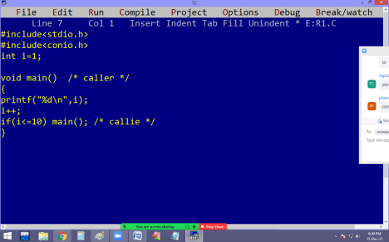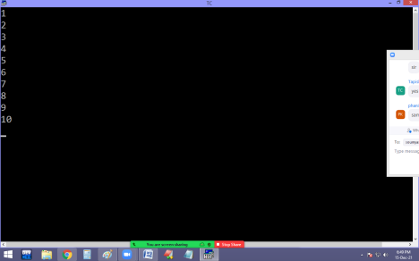
5
Eg: Finding factorial using recursion:
#include<stdio.h>
#include<conio.h>
long fact(int n)
{
if(n!=0) return n * fact(n-1); else return 1;
}
void main()
{
int n;
clrscr();
printf(“Enter a no “); scanf(“%d”, &n);
printf(“%d Factorial = %ld”, n, fact(n));
getch();
}
O/P: Enter a no 5
6
5 Factorial = 120
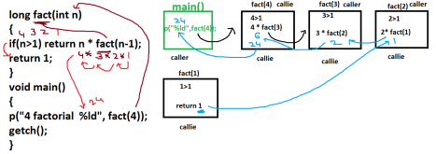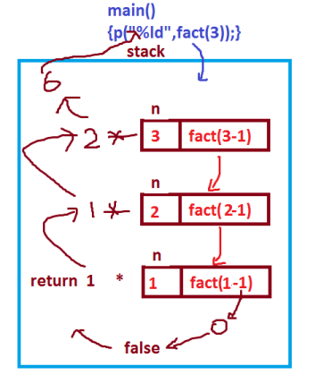
7
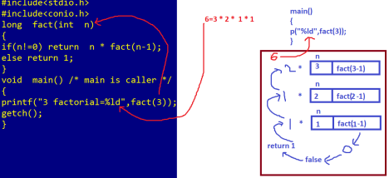Finding power using recursion:
#include<stdio.h>
#include<conio.h>
long power(int b, int p)
{
if(p!=0) return b * power(b, p-1); else return 1; }
void main()
{
int b,p;
printf(“Enter base, power values “);
8
scanf(“%d %d”,&b,&p);
printf(“%d ^ %d = %ld”, b, p, power(b,p));
getch();
}
Output: Enter base, power values 2 5
2 ^ 5 = 32
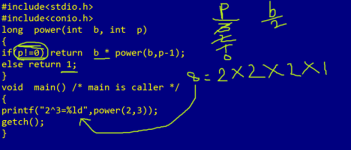Eg : Finding digital sum using recursion
#include<stdio.h>
#include<conio.h>
int s=0; /* global var*/
int dsum(long n)
9
{
if(n!=0)
{
s=s+n%10;
dsum(n/10);
}
return s;
}
void main()
{
long n;
clrscr();
printf("Enter a no");
scanf("%ld",&n);
printf("%ld digital sum = %d",n,dsum(n));
getch();
}
10
Output:
Enter a no: 123
123 digital sum = 6
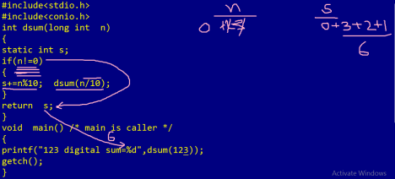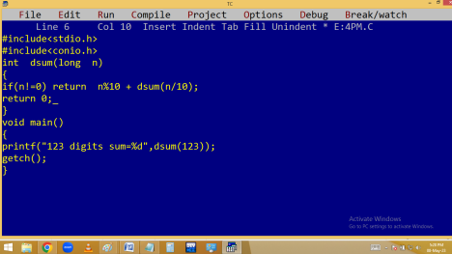
11
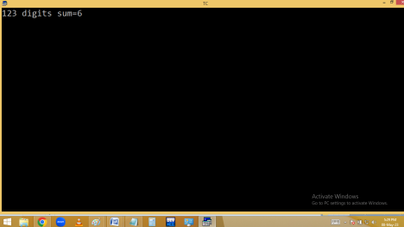Finding prime using recursion:
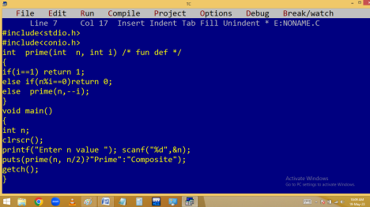
12
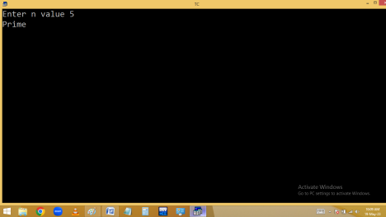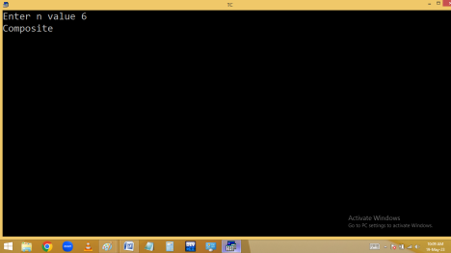
13
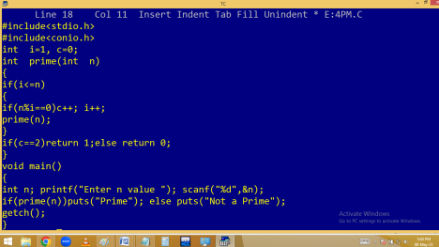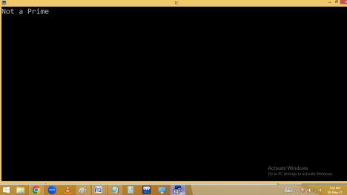
14
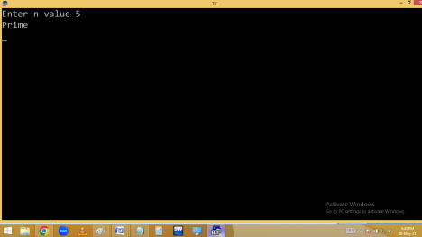STRUCTURE
It is a user defined data type.
It is a complex data type.
It is collection of heterogeneous variables.
Structure is a user defined, complex data type where we can store and manage
15
more than one variable of different data types under one name.
Structure allows to store both primitive and derived data types (arrays, pointers) at one place, under one name.
In real time applications, data is stored in the form of objects. In this situation, we need structures. Structures are the foundation for object oriented.
Primitive and derived data types are designed to work with basic data types like int, float and char.
Primitive and derived data types don’t support real time requirements. Hence
16
we have to use the user defined data type structure.
Structure allows to carry different types of variables at a time.
When structure address is available, automatically all the variables address also available. Due to this search time is reduced.
Structure allows to store information in the form of records.
In data files we are using structures very much.
17
Syntax:
struct [ <structure-tag-name> ] {
datatype variable;
datatype variable;
}
[structure_variables] ;
Here struct is a keyword.
Structure tag name is used to identify the structure and it is optional, but required when structure variables declared in other places of the program.
18
The variables that are declared inside a structure are called structure members. Structure size is sum of all the structure members datatype size.
Without structure members [ empty ] structure size is 1 byte.
Structure variables are the instances [copies] of the structure.
Structure is a blue-print [original copy] to create the structure variables. Structure variable is the physical representation of a structure.
When structure variables declared then only memory allocated for structure members.
19
Every structure should be end with ;
To access the structure members we should have to use the following syntax. structurevariable.structuremember;
It is called calling / accessing / invoking the structure members.
Here . (dot) operator is called
⮚ Member access operator
⮚ Field access operator
⮚ Member of operator
⮚ Membership operator
⮚ Belongs to operator
20
We can declare structure variables in other places of the program by using below syntax.
struct structure-tag-name structure
variables;
Eg: struct stu s1, s2;
Memory allocation for structure variables
21
s1.id=100;/* calling structure member*/ s2.id=200;
22
Eg: Direct initialization of structure members:
It is the process of passing values for structure members, without using scanf() at design time using =.
Note: In direct initialization of structure members, the passing values datatype and structure members datatype should be matched.
When all the structure members are not initialized, they will store the default values as follows.
Int – 0
Float – 0.000000
23
Char – blank space
structures stores 0, 0.00 and blank in int, float and char.
when it is a local structure, without initialization, stores garbage values.
24
25
26
27
Findingstructuresize:
28
29
Reading and printing structure data:
30
31
Array of structure members:
32
33
Pointer structure members:
34
35

